
Bicoastal
ManagementInc.

Project Management Plan

Web Based Platform Project
For
Bonnebell Inc.

PMAN 634 9082 Nov 2, 2018
Professor Agrawal

Varinder Budwal
Bonnie Caudle
Tamekka Corbett
Mary Everett

Table of Contents
Objectives 3
Scope 4
Approach and Organization 5
Overview 3
Budget 6
Resources 7
Risk Management 7
Evaluation Methods 9
Project Closing 11
Project Schedule & Personnel 14
Project communications 12
Project Activity Estimates 15
Project Gantt Chart 16
Project Critical Path 17

OVERVIEW
Bicoastal Management’s Project Management Plan consists of the objectives, dates, scope, budget, resources, risk management, evaluation methods, personnel, and communications involved with the Bonne Bell Project. The following detailed responses to the Bicoastal Management Charter dated October 19, 2018, will confirm the intent of that project charter, as well as show in detail exactly how to achieve those project goals. The necessary milestones, products, resources and activities required on the project are listed below. This project management plan will be approved by the project sponsor, Ms. Tamekka Corbett. This paper will show how Bicoastal Management controls, manages, and executes the project.
The Bicoastal Management Project Plan will provide a definition of the project, including the project’s goals and objectives. Additionally, the Plan will serve as an agreement between the following parties: Project Sponsor, Steering Committee, Project Manager, Project Team, and other personnel associated with and/or affected by the project.The Project Plan defines the project purpose, business and project goals/objectives, scope/expectations, roles/responsibilities, assumptions/constraints, project management approach, ground roles for the project, project budget, project timeline, and the conceptual approach for Bicoastal Management.
OBJECTIVES
The project goals and objectives for this project will focus on implementing Bonnebell Inc. that it reduces costs which allows Bonnebell Inc. to improve efficiency whole capitalizing its technology. The recommended WBP project will migrate the data of the current system to the new web-based platform to keep the integrity of the data and allowing time to train all the employees and managers on their responsibilities and administrative functions. This web-based platform is compatible with other IT systems and will improve the efficiency and accuracy throughout the company. Employees will be able to enter/edit the timesheet data at any time and from any location into the mainframe system. The timesheet and payroll data will be accessible for quality control and reporting purposes which will reduce the need for staff to analyze the data. Employees will have the capability to register for training which will take the burden off managers and the team. By doing this, this will facilitate coordination and information sharing both internal and external to the participating organizations. This will also enhance the ability and effectiveness of staff to perform their roles which will provide a open, flexible, and reliable workplace for the future. The program is an innovative security awareness that delivers a range of high-quality awareness of some materials that cover a unique security information. This keeps the program rolling regularly, introducing and later revisiting a broad range of information security issues from different perspectives. The continuous feed of engaging and important awareness materials is created to build and support a sustained, long-term development in security awareness, leading to a deep-rooted and extensive security culture completely through Bonnebell Inc.
SCOPE
Once moving to a more centralized administrative platform, Bicoastal Management will set up web-based platforms to manage its employee payroll systems, while the employee administrative functions will be combined in the similar manner. The web-based technology will manage their payroll, reporting, training and other tasks. The company will benefit from accurate financial reporting as the managers’ capability to enter and update financial metrics is greatly improved with this loss of tedious functions. By freeing up the managers’ duties, this will enable real-time access as it reduces errors and improves the cycle time.
APPROACH AND ORGANIZATION
Once moving to a more centralized administrative platform, Bicoastal Management will set up web-based platforms to manage its employee payroll systems, while the employee administrative functions will be combined in the similar manner. The web-based technology will manage their payroll, reporting, training and other tasks. The company will benefit from accurate financial reporting as the managers’ capability to enter and update financial metrics is greatly improved with this loss of tedious functions. By freeing up the managers’ duties, this will enable real-time access as it reduces errors and improves the cycle time. This approach differs markedly with traditional security awareness programs that have typically relied on an annual awareness and training session for timesheet data for all employees. Experience has shown that once a year awareness training sessions are not useful in practices but employees often forget the security messages and return to their old habits if they’ve visited andanswered to the training in the first place. It is disruptive and costly to put large percentage of employees through these events. On top of that, the format rigorously constrains the amount of information that can sensibly be conveyed, meaning that much of the content becomes insignificant and annoying to attendees and doesn’t stick.
There is a connection between systems possibly physical ones that are a traditional private data center where cables, routers, and switches connect the servers and networks. This is also wireless or virtual like a WiFi internet connection or telecommunications service. With equipment and resources being shared, there is an increased risk of the attack affecting one component may spread that effect to other systems on the network. The level of security assurance is essential to enable a network to perform its intended function whether its users being able to communicate or the sharing and storage of documents like data which gives access to share infrastructures or external resources.
BUDGET

The project manager must monitor all project requirements, while keeping an eye on all resources, costs and time. Finishing projects on time or early, as well as under budget goes a long way to continuing to find work as a project manager; crucial if a project manager wants to keep their job. The most important part of managing a project is the understanding and knowledge of what the stakeholder wants done in their project, how much they are willing to spend and how long the project will take. The stakeholder’s wants and needs must always be considered first and foremost before starting the project, and must match up with what the project manager is doing. The actual cost of work performed, the planned values, and the tracking of all finances including monitoring escalated costs, is a large responsibility of the project manager. Even suppliers that could not meet quoted obligations and other surprises need to be defined with money adjusted. Impacted higher costs by unforeseen circumstances must be avoided. Informing all project team members about staying on track with the budget, will keep a tighter control over wasted time.
Bicoastal Management is adding web-based administrative platforms to Bonnebell, Inc, adding value by helping to facilitate the employee administrative functions, annual trainings, payroll systems, and other employee incentive programs. Reducing costs for the many administrative functions with this new web-based platform helps to diminish costs and save money for the Bonnebell, Inc organization. Keeping the same strategy and purpose, companies can strategically continue to train while maintaining their high focus. Bonnebell Inc, will save $247,239.00 in the first year, a high indicator of a positive and fruitful experience.
RESOURCES

A resource plan is mandatory for good resource management. Starting out with a highly detailed schedule, including all types of resources on hand for each task must be completed. The organization’s resources are materials, equipment, knowledge, people, and time. The teams of people that will execute the project plan, the equipment necessary, the project management software, the area the work will take place, the vendors, and the outside contractors all come into play in effective resource management. A flexible resource plan is critical in effective management. With many unknown factors, it is not always possible to have all resources available at the start of the project, thus a resource allocation plan is effective when dealing with scarce resources. Project managers must monitor their resources at all times, taking advantage of every opportunity to use the Learning Curve Theory by having the same personnel doing repetitive jobs to save valuable time. Reviewing their people working on a project and pulling them off whenever possible, to save money helps to keep their budget on track. Project managers must strive to keep the project budget on track.
PROJECT RISK MANAGEMENT
“Risk is a possibility of loss or injury. Project risk is an uncertain event or condition that if it occurs, has an effect on at least one project objective. Risk management focuses on identifying and assessing the risks to the project and managing those risks to minimize the impact on the project” (Defining Risk, 2015). BiCoastal Management will identify, assess, monitor and control any risks throughout the lifecycle of the project, with monthly assessments included in the status report. The purpose is to make sure that all levels of risks are taken into account to result in a successful project. Some of the risks that need to be taken into consideration include other software in the market that could be similar, time, database interface issues, security, debugging, and software errors. A risk factor is then calculated and risks with a factor of 9 or greater will have a dedicated mitigation plan developed.

Risk Identification and Assessment
No. | Risk | Category | Probability | Impact | Risk Factor
1 | The customer decides system does not meet needs | Customer | 3 | 4 | 12
2 | Product team falls behind schedule | Management | 3 | 3 | 9
3 | Software execution time lags system response | Programming | 5 | 1 | 5
4 | Software contains bugs/logic errors | Programming | 5 | 1 | 5
5 | Hacker corrupt privileged database data | Security | 3 | 3 | 9
6 | Personnel leave/are removed from the project | Management | 1 | 3 | 3
7 | Product size too large | Programming | 1 | 3 | 3
8 | Specific browser fails to correctly display application | Software | 1 | 2 | 2
Probability: (1-Low, 3-Med, 5-High) Impact:(1-Negligible, 2-Marginal, 3-Critical, 4-Catastrophic)

Risk Monitoring and Control
All team members are responsible for monitoring the project’s risk factors. Each development team member should have the program installed and running on all computers within the company. Any issues which represent a risk to the successful completion of the project should be reported to the project manager. The project manager will outline the problem and possible solutions and email a copy to each team member. The problem will then be put on the agenda for the next team meeting and discussed in detail to find a solution.
The activities of the risk planning process are as follows:
- Risk scenarios are developed for high severity and high impact risks.
- Resolution alternatives are considered for those risks.
- A resolution approach is selected.
- An action is taken, or a plan is developed.
Project Evaluation Methods
Project evaluation is a very important part of controlling the project and its end result. BiCoastal management will conduct several evaluations throughout the lifecycle of the project. We will start with the pre-evaluation on selecting the project, an ongoing evaluation, and then a post evaluation will be conducted and we will keep notes on all the factors that have arisen during the project. The team will meet on a weekly basis, either in person meetings or via Skype. All tasks will be evaluated and the tasks will be evaluated on a daily basis and reviewed by the project manager for efficiency.
Our team will first gather all information; state our purpose, main goals, and our audience. The most important task is to get a clear understanding of our future web-based platform purpose. We will develop a questionnaire to help develop the best strategy for the project. At the next stage of the development cycle, the developer of the platform creates the data that can give the customer an opportunity to judge how the entire site will look like. Next step is the design phase, where our platform takes shape. All the visual content, such as training materials, images, and videos is created at this point. The website layout of the platform is the result of the designer’s work. After Bonnebell, Inc reviews the layout and sends feedback, the team will continue to meet with the designer and make any changes, if at all, until the customer is satisfied. This can take four to twelve weeks.
Content writing and compiling usually overlaps with other stages of the creation of the platform and its role cannot be underestimated. At this step, it is necessary to put in writing the very essence you’d like to communicate to the audience of the website and add calls-to-action. Content writing involves also text editing, writing new text, compiling text, etc; which takes time and effort. It is better when all website content is provided before or during website coding.
The next step is coding, finally creating the platform. Graphic elements that have been designed during the previous stages should be used to create an actual website. Frameworks and CMS should be implemented to make sure that the server can handle the installation and set-up smoothly. All static web page elements that were designed during the mock-up and layout creation should be created and tested. A deep understanding of the development and technology that is being used is crucial at this phase.
Testing is probably the most routine part of the process. Every single link should be tested to make sure that there are no broken links among them. Every form and script must be checked. A spell-checking software is run, to find typos. Code validators are used to check if the code is following the current web standards. After all checks are complete, it is uploaded to the server. An FTP (file transfer protocol) software is used for that purpose. After the files are deployed, a final test needs to be run to be sure that all information has been installed correctly. Maintenance needs to be performed. A feedback system will also help to detect possible problems. A CMS is very important, regular updates will prevent the system from bugs and decrease security risks.

Project Close-out and Completion
The following section identifies the criteria required to complete the project along with any outstanding items which still need to be processed and undertaken.

Completion Criteria:
Category | Criteria | Achieved Y/N
Objectives | - The project vision has been achieved  - All project objectives have been achieved
Benefits | - The full benefits have been realized
Deliverables | - All deliverables have been completed  - All deliverables have been accepted by the customer

Outstanding Items

Following are outstanding items which will still need to be addressed even though the project has satisfied the above completion criteria.

Item | Action | Owner
Activities
Risks
Issues

Project Communications
For our project to be a success, Bicoastal Management, Inc. has taken the time to set up a Communications Management Plan to formally identify all critical communication channels necessary for this project. This framework will aid to better communicate with our stakeholders as well as our project team. Table 1 illustrates to whom information will be distributed to, what to communicate, the frequency of communication, and which Bonnebell project team member is the point of contact for the dissemination of information. Bicoastal Management, Inc will communicate vital information which includes project process, project status, accomplishments, conflicts, any areas of concern, and milestones in a clear and effective manner. Assurance of effective communications, on this project, will be led by the project manager.
Meetings will be conducted weekly by the project team to discuss administrative matters, decisions that need to be made, action items, as well as due dates and status of the projects. Information from these meetings will utilized for the project and then the Project Manager will compile the information to be given to the project sponsor via email and hard copy on a biweekly basis. Since members of the project team live on different coast, the team will use conference calls to conduct weekly and bi-weekly meetings. Monthly and Quarterly meeting will be conducted in person. If determined, project team members will use encrypted email systems for dispersing formal information and Google Drive for compiling information.

Participants/ Distribution/ audience | Communication Type | Description/ Information | Deliverables/ Category | Format/ Delivery Method | Frequency | Who is Responsible/ Owner
Project Team | Weekly Project Team Meeting | Project Execution Issues, and Challenges | Project Status | Team Meeting via conference call | Weekly | Project Manager
Project Sponsor, Project Team and stakeholders | Status Report | Summary of Project status | Status Report | Email, Hard Copy | Bi-Weekly | Project Manager, Approved Stakeholders
Project Sponsor, Project Team, and Stakeholders | Project Monthly Review (PMR) | Present metrics and status to project team members and project sponsor | Presentation of Status and Metrics | In Person, Hard Copy | Monthly | Project Manager
Project Team | Detailed Status Reports | Intricate details of the progress of tasks and phases | High Level Detailed Project Status, complications, accomplishments | In Person, Hard Copy | Quarterly | Project Manager
Project Sponsor, Project Team and Stakeholders | Project Gate Reviews | Present closeout of project phases and kickoff next phase | Phase completion report and phase kickoff | Conference Call | As needed | Project Manager
Project Team | Technical Design Review | Review of any technical designs or work associated with the project | Technical Design Package | Conference Call and email | As needed | Project Manager
Project Team | Conflicts/ Area of Concern | Email to | Status | GroupMe, Email, Team Meeting | As needed, Ongoing | Project Manager
Table 1. Project Communications plan utilized by Bicoastal Management, Inc.
Personnel Project team directory for all communications:
Name | Title | Email | Phone
Budwal, Varinder | Executive Sponsor | v.budwal@BCI.net | xxx-xxx-xxxx
Brown, Lisa | Technology Support | l.brown@BCI.net | xxx-xxx-xxxx
Corbett, Tameeka | Project Manager | t.corbett@BCI.net | xxx-xxx-xxxx
Everett, Mary | Process Improvement | m.everett@@BCI.net | xxx-xxx-xxxx
Caudle, Bonnie | President, BonneBell | b.caudle@bonnebell.com | xxx-xxx-xxxx
Table 2. Personnel Directory

Project Schedule
Bicoastal Management, Inc. has created this project schedule to be an effective schedule management tool to confirm tasks are completed on time, resources are allocated appropriately, and to help ensure project performance is accurately measured. The estimates and project schedule for the web-based platform project for Bonnebell, Inc. was drafted using the project’s Work Breakdown Structure, project milestones and deliverables.
The WBS helped to determine due dates of deliverables. From there, work packages and activity definition were quantified and sequence to determine a preliminary schedule. Once estimated, resources will be assigned to work packages to complete the schedule development. Upon completion of resource estimating, the project team will review the schedule. All members must agree upon proposed work package assignments, durations, and schedule. Once the entire project team agrees the project sponsor will review and approve the schedule as the base line.

Task Name | Duration (days) | Start | Finish
Project Plan Review | 13 | 12/13/17 | 01/01/2018
Project Kickoff | 24 | 01/01/2018 | 02/01/2018
Phase I Complete | 60 | 01/01/2018 | 04/01/2018
Phase II Complete | 45 | 04/02/2018 | 06/01/2018
Employee Education Programs | 20 | 05/07/2018 | 06/01/2018
Training Employees on Administrative Functions | 20 | 05/07/2018 | 06/01/2018
Employee Bag Lunch Administrative Training Classes | 20 | 05/07/2018 | 06/01/2018
Employee Educational Programs for School Credits | 20 | 05/07/2018 | 06/01/2018
Training Employees on New Payroll System | 20 | 05/07/2018 | 06/01/2018
Phase III Complete | 53 | 06/04/2018 | 08/15/2018
Phase IV Complete | 46 | 08/13/2018 | 10/15/2018
Closeout - Project Completed | 61 | 10/08/2018 | 12/31/2018
Table 3. Summary of project activity estimates for the new Bonnebell project.
Roles and Responsibilities of the entire project team are as follows:
The project manager along with the project team will responsible for creating the project schedule. MS Project will be the platform used. The project manager will then oversee defining and facilitating work packages, task duration and resources. Once created, the project schedule will be validated by the project team, stakeholders, as well as the project sponsor. The project manager will obtain schedule approval from the project sponsor and baseline the schedule.
The project team will aid in defining and facilitating work packages, task duration and resources. After reviewing the schedule, the project team will validate the proposed schedule. Once the project schedule is approved the project team will proceed to perform their team roles.
The project sponsor will be present and active at all reviews held for the proposed schedule. The approval of the schedule by the project sponsor will be the baseline for the project.
Project stakeholders will be present and active at all reviews. In addition, they will assist in the validation of the project schedule.
Project Gantt Chart
The Gantt chart in Figure 1 illustrates the duration of each work package and activity definition tasks with within the project. The Gantt chart was created to clearly and effectively communicate project dependencies, manage resources, track and monitor progression of the project with all members of, Bonnebell, Inc.’s appointed representative(s), Bicoastal Management, Inc.’s project team, and resource vendors.

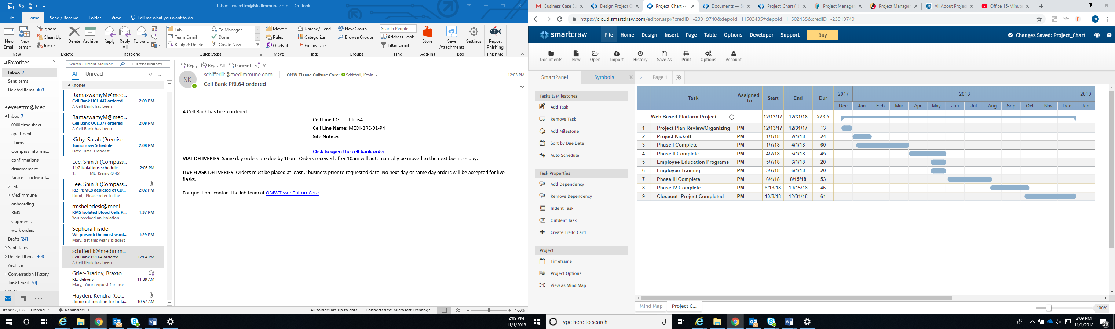
Figure 1. This figure illustrates a portion of the Gantt chart for the WPP.

Project Critical Path
The Project Critical Path calculates the longest of planned project network activity, as well as the earliest and latest that each activity can start and finish without prolonging the completion of the project or extending the end date for the completion of the project. Calculating the Project Critical Path will aid in determining which critical and which can be delayed later within the timeline of the project without making it longer. Tasks within the schedule will be monitored for their time progress by referencing the project schedule and Gantt charts. If a constraint arises, the company will determine if individual tasks on the critical path can be delayed to not create a critical path drag. Figure 2, the network diagram, shows the project schedule, tasks sequence and relationships.

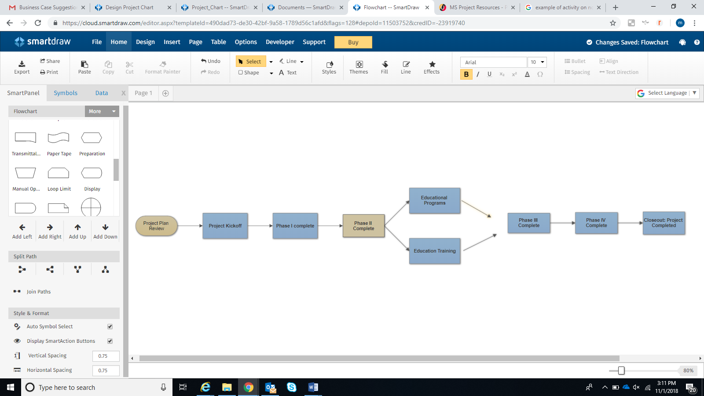
Figure 2. Network activity diagram

References
Brownlee, D. (2008). The secrets to running project status meetings that work! Paper presented at PMI® Global Congress 2008—North America, Denver, CO. Newtown Square, PA: Project Management Institute. Retrieved from https://www.pmi.org/learning/library/secrets-running-project-status- meetings-7009
Defining risk. (2015). Retrieved from https://pm4id.org/chapter/11-1-defining-risk/

Hess, R. J. (2002). Stuff happens: planning for disaster in a multitasking environment. PM Network, 16(6), 40–47

https://www.smartdraw.com/gantt-chart/examples/

Managing Change in Organizations: A Practice Guide (2013)

Martin, P. K. & Tate, K. (2000). What's in a project plan? PM Network, 14(4), 33

Martinez, E. V. (1994). Executives to project manager: get a plan! PM Network, 8(10), 8- 10.

Means, J., Adams, T., & Spivey, M. (2007). Facilitating effective project meetings. Paper presented at PMI® Global Congress 2007—North America, Atlanta, GA. Newtown Square, PA: Project Management Institute. Retrieved from https://www.pmi.org/learning/library/four-techniques-facilitate-project- meetings-7249

Mezak, S. (2016, June 22). How to succeed with a platform business model. Forbes Online. Retrieved from
https://www.forbes.com/sites/forbestechcouncil/2016/06/22/how-to-succeed-with- a-platform-business-model/#7a29dc38405b

Serghei Floricel, P. (2011). Refining the Knowledge Production Plan.

Spears, W. (2014). Effective practices for change management action. Paper presented at PMI® Global Congress 2014—North America, Phoenix, AZ. Newtown Square, PA: Project Management Institute

Thamhain, H. J. (1989). Validating technical project plans. Project Management Journal, 20(4), 43–50

Truhlar, P. B. (2000). WBS.com(ponents)—building a better WBS for object technology. Paper presented at Project Management Institute Annual Seminars & Symposium, Houston, TX. Newtown Square, PA: Project Management Institute.

